09:10 Anonymous so far: Hello - yesterday, all my trades had STOPs on them that I set before entering each trade and now they are gone.
1. Where did they go?
2. What am I doing wrong?
My goal is to create a threshold that exits a trade if the stock gets lower than I wish. What is the proper way to do that? I always trade at market value by the way.
09:10 admin: Thank you for chatting with us. We appreciate your patience as the next available associate will be with you as soon as possible.
09:11 Gary_H: Thanks for chatting in to Schwab support today. My name is Gary
09:11 Anonymous so far: hey Gary thanks for joining
09:12 Gary_H: Let Me check those stop orders- If the time in force for hem was "DAY" - then they expire at the end of that regular session . If you want them to work additional regular sessions- use GTC ( good 'till cancel" time in force
09:12 Anonymous so far: ohhhhh
09:12 Anonymous so far: ok that makes sense
09:12 Gary_H: 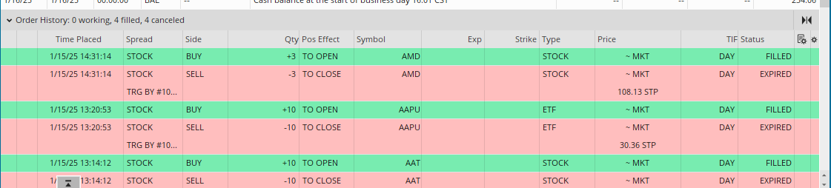
09:13 Gary_H: Yes- each was set to DAY
09:13 Gary_H: The space to set of change TIF is just right of price and order type in the ticket
09:13 Anonymous so far: got it thank you Gary. Am I doing that correctly other than the DAY setting?
09:14 Gary_H: Yes. they lok good other than that
09:14 Anonymous so far: can you show me where to set those?
09:14 Anonymous so far: Where is the "DAY" setting
09:14 Gary_H: 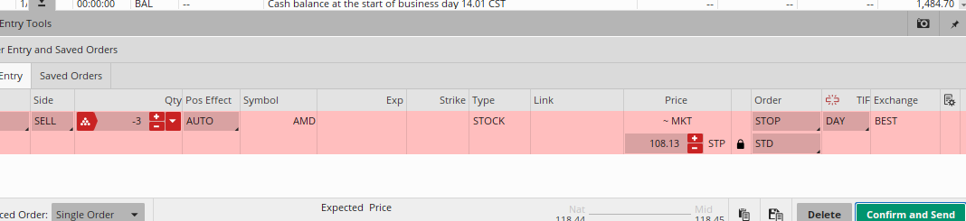
09:14 Gary_H: Between stop and best at the right side
09:16 Gary_H: Are you seeing the way now? Just click DAY in the new order- and change to GTC
09:16 Anonymous so far: 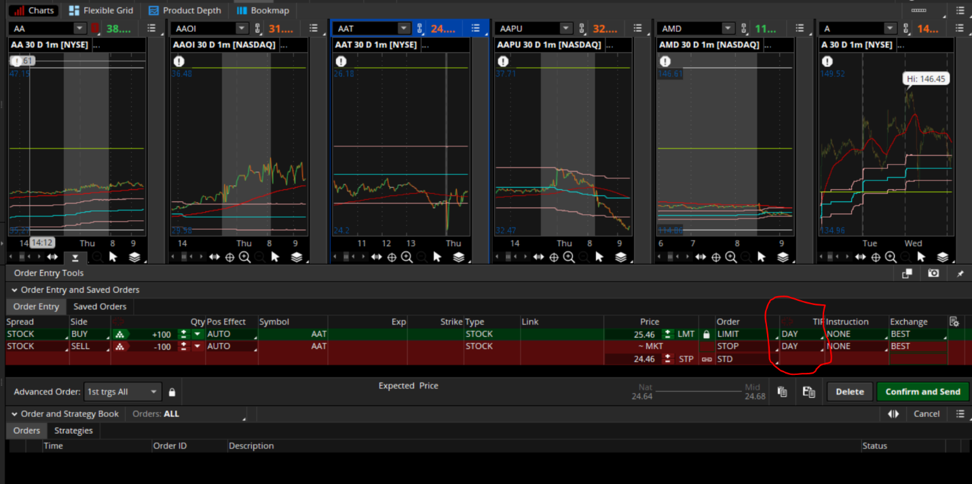
09:16 Gary_H: Yes- that's the place - make this GTC
09:17 Anonymous so far: understood. what is the other GTC option on there?
09:17 Gary_H: EXT_GTC is a setting that allows limit orders to work in ALL sessions- inc;luding the extended ones- ( pre market and post ) but stop cannot work in those
09:18 Gary_H: To trade most stocks or ETF's in the extended sessions - pre market or post - you only need to change the TIF ( time in force ) from DAY to EXT or GTC_EXT - and only use limit orders....no stops or market orders will be accepted
09:18 Anonymous so far: understood! Thank you sir!!
09:18 Gary_H: All set? Can I try to help with anything else?
09:18 Anonymous so far: I'm good now you have a great day
09:18 Gary_H: You too! Thanks for choosing Schwab... chat in again anytime

